**Tema 3**

Nume: Pop Maria

Grupa: 232

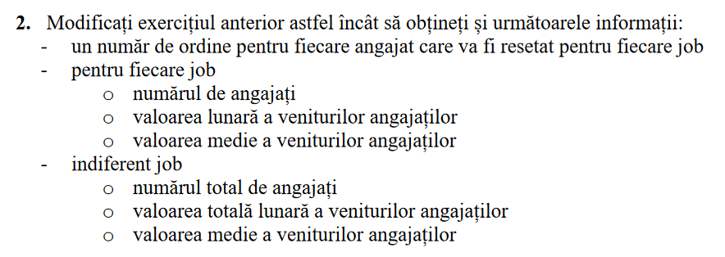

DECLARE

type tip_joburi is table of jobs.job_id%TYPE;

cursor c (job_curent jobs.job_id%TYPE) is

select e.last_name, e.first_name, e.salary

from employees e, jobs j

where j.job_id = e.job_id and j.job_id = job_curent;

joburi tip_joburi := tip_joburi();

titlu_job jobs.job_title%type;

nume_angajat employees.first_name%type;

prenume_angajat employees.last_name%type;

salariu employees.salary%type;

numar_joburi number;

numar_salariati number;

numar number := 0;

numar_total number := 0;

salariu_total_job number := 0;

salariu_mediu_job number;

salariu_total number := 0;

salariu_mediu number := 0;

begin

select count(*)

into numar_joburi

from jobs;

joburi.extend(numar_joburi);

select j.job_id

bulk collect into joburi

from jobs j;

for i in joburi.first..joburi.last loop

select job_title

into titlu_job

from jobs j

where j.job_id = joburi(i);

numar := 0;

salariu_total_job := 0;

select count(*)

into numar_salariati

from employees e, jobs j

where e.job_id = j.job_id and j.job_id = joburi(i);

if numar_salariati = 0 then

DBMS_OUTPUT.put_line('Nu lucreaza niciun angajat ca ' || titlu_job);

elsif numar_salariati = 1 then

DBMS_OUTPUT.put_line('Un angajat lucreaza ca ' || titlu_job);

elsif numar_salariati < 20 then

DBMS_OUTPUT.put_line(numar_salariati || ' angajati lucreaza ca ' || titlu_job);

else

DBMS_OUTPUT.put_line(numar_salariati || ' de angajati lucreaza ca ' || titlu_job);

end if;

open c(joburi(i));

loop

fetch c into nume_angajat, prenume_angajat, salariu;

exit when c%NOTFOUND;

DBMS_OUTPUT.put_line(numar + 1 || '. ' || nume_angajat || ' ' || prenume_angajat || ': ' || salariu);

numar := numar + 1;

salariu_total_job := salariu_total_job + salariu;

numar_total := numar_total + 1;

end loop;

close c;

salariu_total := salariu_total + salariu_total_job;

if numar = 0 then

DBMS_OUTPUT.put_line('Nu exista niciun angajat');

else

salariu_mediu_job := salariu_total_job / numar;

DBMS_OUTPUT.put_line('Salariul total al angajatilor este ' || salariu_total_job || ', iar cel mediu este ' || salariu_mediu_job);

end if;

DBMS_OUTPUT.new_line();

end loop;

salariu_mediu := salariu_total / numar_total;

DBMS_OUTPUT.put_line('Salariul total al tuturor angajatilor este ' || salariu_total || ', iar cel mediu este ' || salariu_mediu);

end;

/

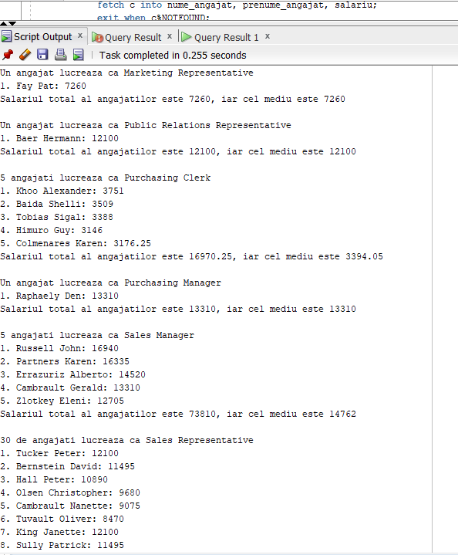



DECLARE

type tip_joburi is table of jobs.job_id%TYPE;

cursor c (job_curent jobs.job_id%TYPE) is

select e.last_name, e.first_name, e.salary, e.commission_pct

from employees e, jobs j

where j.job_id = e.job_id and j.job_id = job_curent

order by e.salary desc;

joburi tip_joburi := tip_joburi();

salariu_angajat employees.salary%TYPE;

titlu_job jobs.job_title%type;

nume_angajat employees.first_name%type;

prenume_angajat employees.last_name%type;

salariu employees.salary%type;

numar_joburi number;

numar_salariati number;

numar number := 0;

procentaj_comision number := 0;

begin

select count(*)

into numar_joburi

from jobs;

joburi.extend(numar_joburi);

select j.job_id

bulk collect into joburi

from jobs j;

for i in joburi.first..joburi.last loop

select job_title

into titlu_job

from jobs j

where j.job_id = joburi(i);

select count(*)

into numar_salariati

from employees e, jobs j

where e.job_id = j.job_id and j.job_id = joburi(i);

salariu_angajat := 0;

numar := 0;

if numar_salariati < 5 then

DBMS_OUTPUT.put_line('Lucreaza mai putin de 5 angajati ca ' || titlu_job);

else

DBMS_OUTPUT.put_line(titlu_job);

end if;

open c(joburi(i));

loop

fetch c into nume_angajat, prenume_angajat, salariu, procentaj_comision;

exit when c%ROWCOUNT > 5 or c%NOTFOUND;

if salariu <> salariu_angajat or salariu_angajat = 0 then

numar := numar + 1;

salariu_angajat := salariu;

end if;

DBMS_OUTPUT.put_line(numar || ' ' || nume_angajat || ' ' || prenume_angajat || ' ' || salariu);

end LOOP;

close c;

DBMS_OUTPUT.new_line();

end loop;

end;

/

